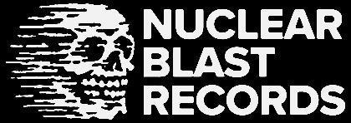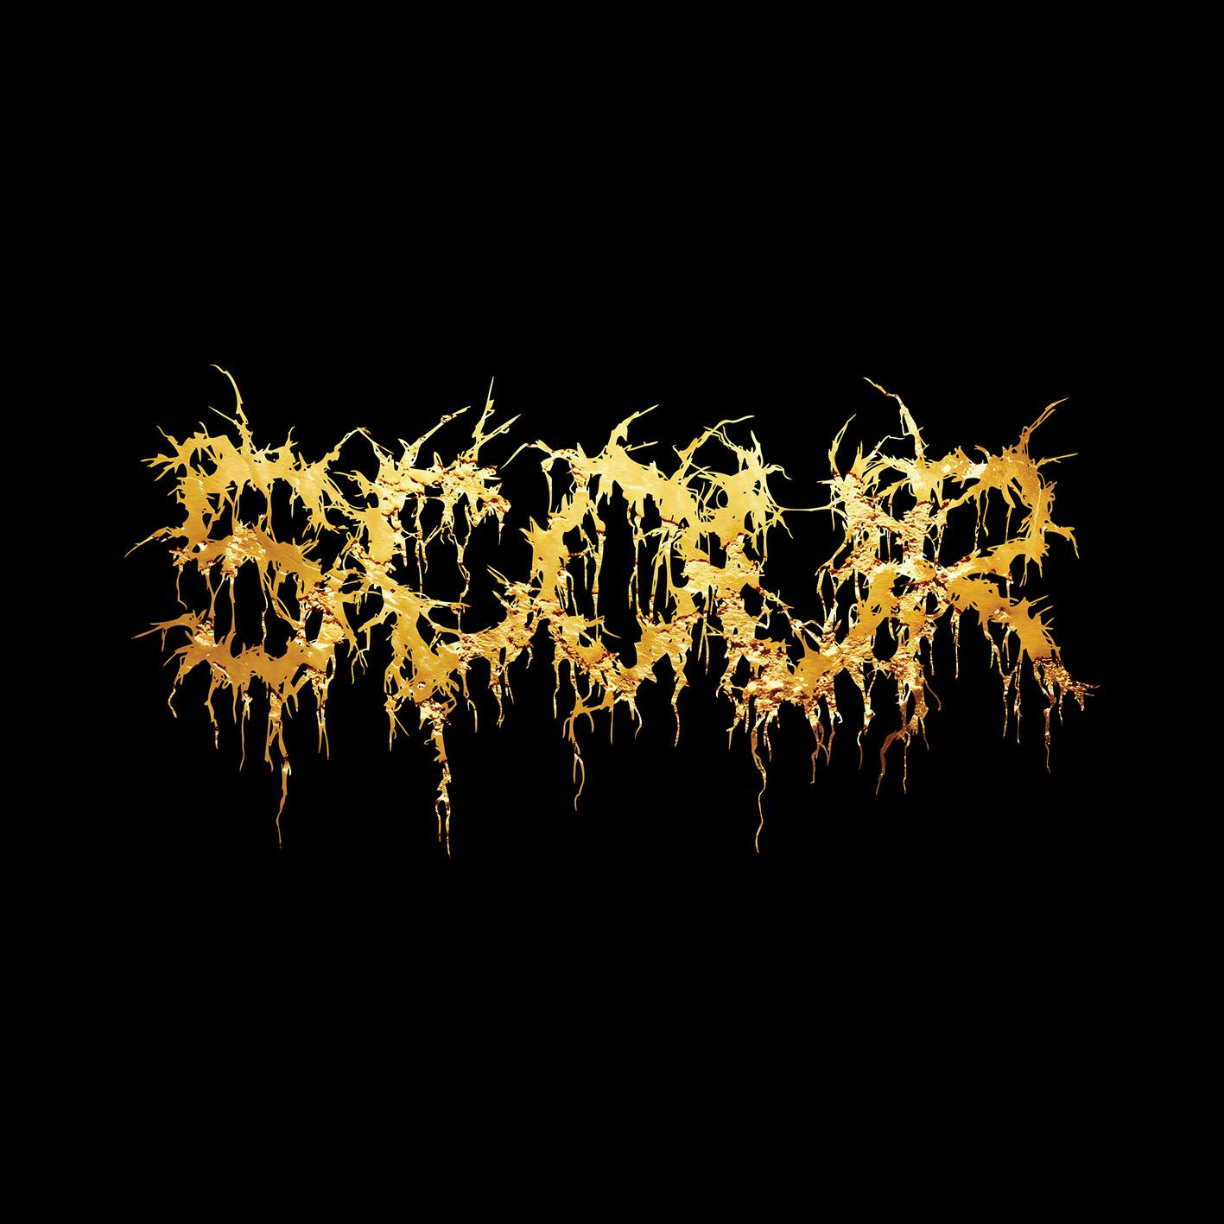

**SCOUR**

*Gold*

*Release Date: February 21, 2025*

| **Line up:** | **SCOUR online:** |
| --- | --- |
| **Philip H. Anselmo** | Vocals  **Derek Engemann** | Guitar, Backing Vocals  **John Jarvis** | Bass, Backing Vocals  **Mark Kloeppel** | Guitar, Backing Vocals  **Adam Jarvis** | Drums | www.facebook.com/scourband  www.instagram.com/scour_official/?hl=en  www.youtube.com/c/SCOUROFFICIAL  [www.x.com/scour_official](https://x.com/scour_official)  www.scourofficial.bandcamp.com/ |
|  |  |

**SCOUR** is an extreme metal supergroup featuring an impressive lineup of heavy music veterans, including **Philip H. Anselmo** (PANTERA, DOWN), **Derek Engemann** (PHILIP H. ANSELMO & THE ILLEGALS), **John Jarvis** (NEST, AGORAPHOBIC NOSEBLEED), **Mark Kloeppel** (MISERY INDEX), and **Adam Jarvis** (PIG DESTROYER, LOCK UP). Formed in 2015, **SCOUR** quickly made their mark with the blistering debut single "**Dispatched**." Their first release, ***The Grey EP*** (2016), came via **Anselmo's Housecore Records**, followed by The Red EP in 2017. In 2020, **SCOUR** unleashed their most aggressive effort yet, ***The Black EP***, released under Housecore and **Nuclear Blast Records**, featuring guest appearances from notable figures like **Erik Rutan**, **Pat O’Brien**, and actor **Jason Momoa**.

In 2024, **SCOUR** elevated their intensity with the announcement of their first full-length album, ***Gold***, which includes a guest solo by **Gary Holt** (**SLAYER,** EXODUS). Recording for ***Gold*** began in February 2023 at **Nodferatu’s Lair** - Philip Anselmo’s personal studio and rehearsal space - which saw the band highly engaged in a concentrated effort toward a truly diabolical composition; with Anselmo leading the charge at every turn. One would often find the entire band in the control room in ecstatic debate; meticulously mulling over every blast beat and divebomb. The album was intermittently refined, and lyrical concepts finalized, over the course of 2023 as touring schedules would allow. Anselmo began vocal recordings in the fall of 2023 at ‘The Lair.’ Back-up vocal recordings were then executed by the rest of the band in arena backstage rooms over the course of Pantera’s February 2024 tour, where the full band would also thoroughly review the instrumentation mixes. Once the tracks were finalized by **SCOUR** and mixing engineer **Dennis Israel**, they were then passed to **Fascination Street Studio** in Örebro, Sweden for mastering by **Jens Bogren**.

Deepening the experience set forth in **SCOUR**’s EP trilogy, ***Gold*** pulls the listener through a blistering vortex of speed, aggression, and, above all, absolute horror. Drawing from a deep framework of literary horror masterworks, ***Gold*** guides the listener beyond the realm of death and through the metaphysical anomalies of a disheveled and decaying mind. In-so-which the pall of a savage universe is lifted, an inconceivable puppetmaster revealed, the remaining self of the listener excruciatingly dissolved, and left asking ‘who is it that pulls the strings?”

Musically, **SCOUR** blends the raw aggression of black metal with grindcore, punk, and thrash influences, creating a sound that honors extreme metal’s roots while pushing it into modern territory. Their minimalist approach is relentless and brutal, with tracks like their 2019 cover of Bathory's "Massacre" perfectly embodying this vision.

Despite their relatively short career, **SCOUR** has performed at some of the world’s most prominent festivals, including Roskilde, Hellfest, Tecate Metal Fest, and Maryland Deathfest. With such a powerful pedigree, **SCOUR** remains a dominant force in both live performances and studio recordings, and fans can expect even more from them in the future.